Name- Akash Bhardwaj

Reg No-11019210034

Class -B.Tech CSE-C (DSAI)

**Experiment -1**

Q.1 Write a program to find the solutions of an quadratic equation

**Program**

#include <stdio.h>

#include <math.h>

int main()

{

int a,b,c;

float d, r1,r2;

printf("The quadratic equation is ax^2+bx+c=0");

printf("Enter coefficients a, b and c: ");

scanf("%d,%d,%d",&a,&b,&c);

d = (b*b)-(4*a*c);

if (d > 0)

{

r1 = (-b+sqrt(d))/(2*a);

r2 = (-b-sqrt(d))/(2*a);

printf("There are real and different roots");

printf("root1 = %f and root2 = %f",r1 , r2);

}

else if (d == 0)

{r1 = (-b+sqrt(d))/(2*a);

printf("There are real and equal roots");

printf("root1=root2=%d”,r1);

}

else

{printf("There are Imaginary roots");}

return 0;

}

**Algorithm**

1. Input coefficients a ,b& c
2. Set d=(b*b)-(4*a*c)
3. If(d>0)

Set r1= (-b+sqrt(d)/(2*a))

Set r2= (-b-sqrt(d)/(2*a))

Print “real and different roots”

Print “r1 & r2”

else if(d==0)

Set r1= (-b+sqrt(d)/(2*a))

Print “real and equal roots”

Print “root1=root2=r1”

else

Print ”roots are imaginary”

[End if]

1. End

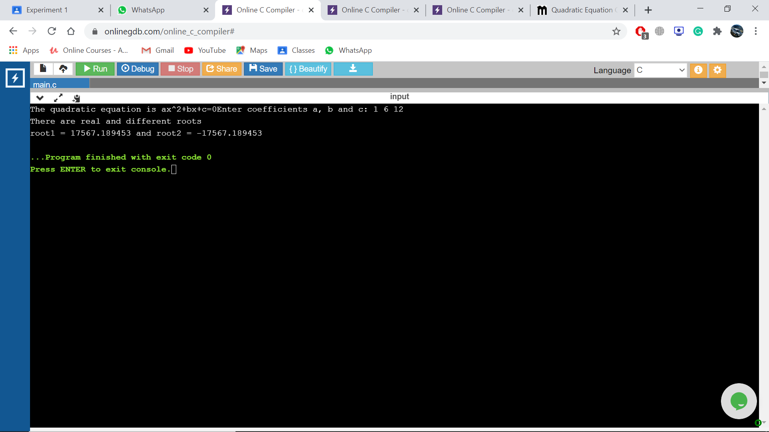

Q.2 Write a program to find the greatest of three numbers.

**Program**

#include <stdio.h>

int main()

{

int a,b,c;

printf("Enter 3 numbers a,b,c");

scanf("%d %d %d",&a,&b,&c);

if(a>b && a>c)

{

printf("%d is the greatest number",a);

}

else if(b>a && b>c)

{

printf("%d is the greatest number",b);

}

else

{

printf("%d is the greatest number",c);

}

}

**Algorithm**

1. Input first number as a, second number as b & third number as c
2. If(a>b && a>c)

Print ”a is the greatest number”

Else if(b>a && b>c)

Print ”b is the greatest number”

else

Print “c is the greatest number”

[End if]

1. End

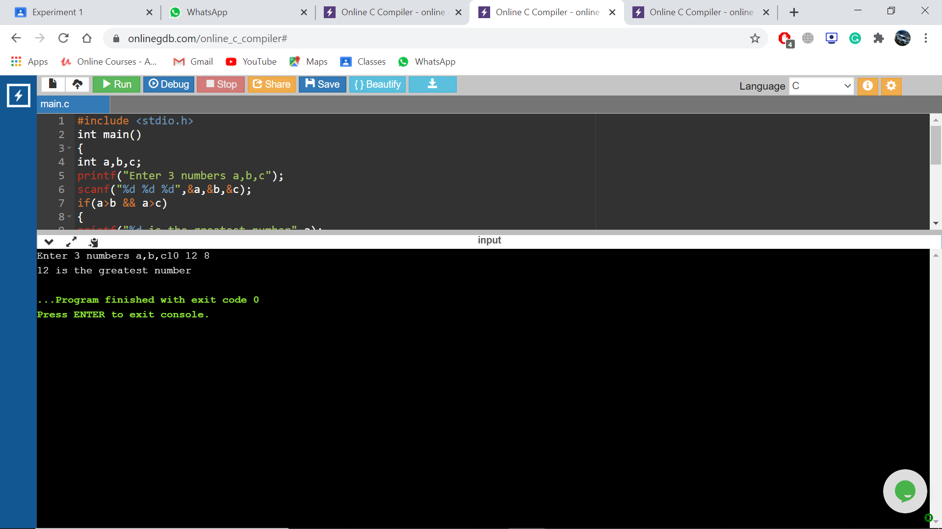

Q.3 Write a program to enter the marks of a student in four subjects. Then calculate the total, aggregate, and display the grades obtained by the student.

**Program**

#include <stdio.h>

int main()

{

int math,eng,com,sci;

float agg,total;

printf("Enter the marks of Maths,English,Computer and Science out of 100" );

scanf("%d %d %d %d ",&math,&eng,&com,&sci);

total=(math+eng+com+sci);

agg=total/4;

printf("The total is %f",total);

printf("The aggregate is %f",agg);

if(agg>=90 && agg<=100)

{printf("The grade is A");}

else if(agg>=80 && agg<=90)

{printf("The grade is B");}

else if(agg>=70 && agg<=80)

{printf("The grade is C");}

else if(agg>=60 && agg<=70)

{printf("The grade is D");}

else if(agg>=50 && agg<=60)

{printf("The grade is F");}

else

{printf("Fail");}}

**Algorithm**

1. Input marks of maths as math ,English as eng, Computer as com & Science as sci
2. Set total = math+eng+com+sci
3. Set agg = total/4
4. if(agg>=90 && agg<=100)

print "The grade is A"

else if(agg>=80 && agg<=90)

Print "The grade is B"

else if(agg>=70 && agg<=80)

Print "The grade is C"

else if(agg>=60 && agg<=70)

Print “The grade is D"

else if(agg>=50 && agg<=60)

Print "The grade is F"

else

Print "Fail"

[End if]

1. End

